Public / Private Key Authentication from Credsb to fghPaybase2

<https://www.youtube.com/watch?v=lwHktjugAYM>

Log onto fghpaybase2 as local admin. Launch Freesshd.

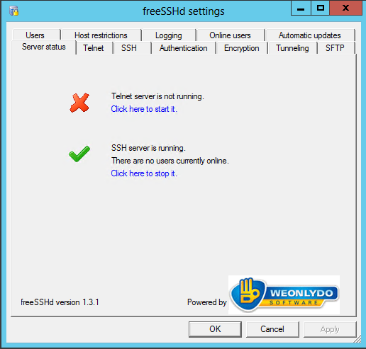

Authentication Tab.

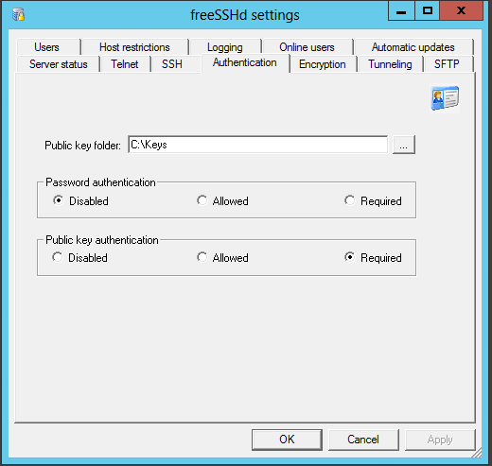

Password Authentication is disabled. Public key authentication Required.

SFTP Path

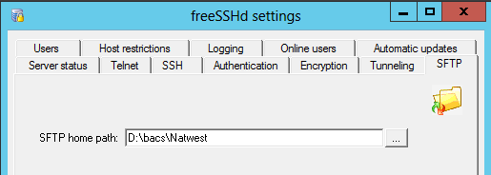

Users. Ftap user added.

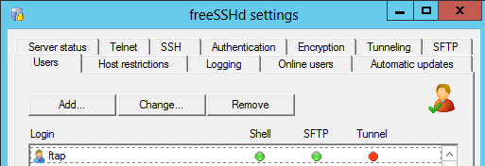

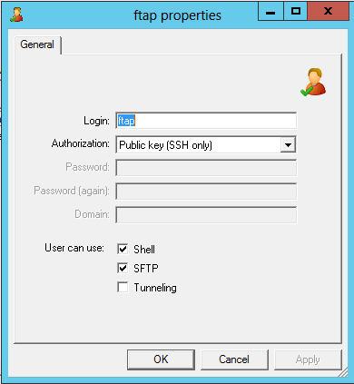

# Creating Keys

Keys created on Credsb. Logged on as ottouk\ftap

Launched puttygen

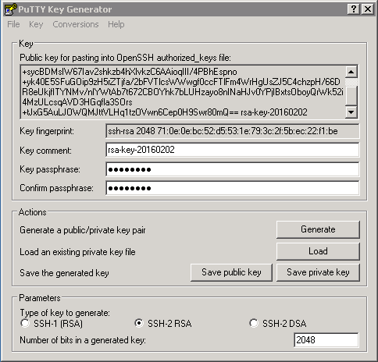

Set to 2048.

Generated keys.

***NO Passphrase***

Copied the text for the public key and saved it as the username with no file extention.

Saved this to fghpaybase2 in C:\keys

Saved private key in folder C:\Keys on Credsb.

# Winscp Setup

Renamed old session to PaybaseDDExport99

Created new session called PaybaseDDExport. (This is because in the script calls this job and it looks in a folder called PaybaseDDExport on Credsb.)

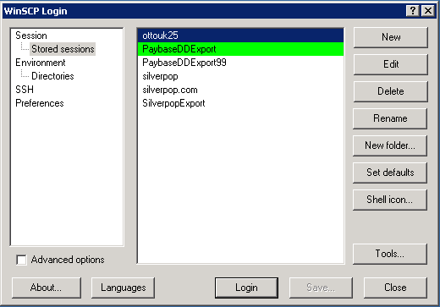

Browse to the private key.

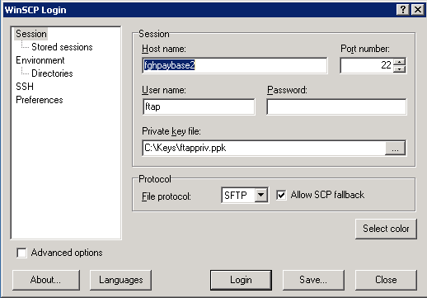

Login…..

# Scripts

All scripts are in credsb D:\scripts.

OPC kicks it off…

1. run_rename_and_sftp_ddfiles.bat
   1. Calls rename_and_sftp_ddfiles.bat
   2. Sets up Logfile
   3. Wraps file and uploads to sar.
2. rename_and_sftp_ddfiles.bat
   1. Rename files.
   2. Run Winscp job PaybaseDDExport
   3. Call sftp_script.bat
3. sftp_script.bat
   1. sftp

Files are moved form Credsb;

D:\FinancierShare\Live\Interfaces\PaybaseDDExport\Out

They sftp to fghpaybase2;

D:\bacs\Natwest\DD_Collections\test or D:\bacs\Natwest\DD_Instructions\test

A scheduled task then runs at 10:00am, C:\scripts\copy_from_ test.bat, to copy from the test folder to the folder above it.